**Introduction of Department**

**Department of Pediatric and Preventive Dentistry, Government Dental College and Hospital, Chhatrapati Sambhajinagar**

**Location:** Government Dental College and Hospital, Chhatrapati Sambhajinagar, Second floor , Room No.217.

The Department of Pediatric and Preventive Dentistry, Chhtrapaji Sambhajinagar was established in 1985. The department aims at the diagnosis & treatment of dental caries and its sequel, teeth malformations and discolorations, thereby restoring the teeth to full function in an aesthetically pleasing manner.

Pediatric Dentistry is the branch of Dentistry which is concerned with comprehensive preventive and therapeutic oral health care of children from birth through adolescence. An upcoming field of dentistry with immense potential, paediatric dentistry aims to eliminate fear at an early age with the inculcation of positive attitudes.

The Department of **Pediatric and Preventive Dentistry, Chhtrapaji Sambhajinagar** caters to maintain a perfect blend of both the clinical and academic arenas of the field. Scope ranges from prenatal counseling of parents to all the dental treatments upto 13 **years** of age. Dental Care of the medically and mentally compromised patients is also taken care of.

Undergraduate students are given discussions on a wide range of topics with special attention placed on interactive case history discussions as well as first hand clinical experience under specialist supervision. They are also encouraged to participate in seminars and posters in order to get introduced to the changing trends and to evoke a fresh interest in the subject. As interns they are trained to deal and expertly manage patients of various age groups with special emphasis on their clinical application of behavior management techniques.

The Department is situated in left wing of the college on the second floor. The department has one large clinical section where both the basic treatment procedures as well as advanced treatments are made available. There is a presence of spacious waiting area. We have a separate unit to treat children with Special Health Care to render proper isolation and comfort to the children. The department also has a well isolated sterilization area, a preclinical lab and play room.

**Goals of the Department**

The goal of our department is to provide basic and advance treatment modalities for children suffering with dental issues. The college aims to provide high quality education to the budding dentist by means of improved understanding of the diagnosis and treatment planning of various types of oral health issues in pediatric patients along with imbibing the students with behavior management skills.

**Mission and Vision**

* To foster the development of dentist who will brining profound integrity and character to every endeavor, while demonstrating the highest quality clinical knowledge and expertise.
* The Students should achieve academic excellence, Provide the best oral health care, and engage in research scholarship, and creative endeavors to improve the health of the highly diverse populations in India.

**Activities :-**

THEORY CLASSES- The undergraduate students begin with lectures in the III year of BDS .Theory (65 lecture hours) - III yr (20 hrs) and IV yr (45hrs).

CLINICAL TRAINING- Detailed case history and discussion, Oral prophylaxis, Restorative procedures, Extractions, Topical fluoride applications procedures are taught in their clinical postings.  
Practical (170 hrs) - III yr (70 hrs) and IV yr (100hrs).

(Total- 235 hrs.)

Seminar presentation- The students are required to present two seminars, one minor at the end of the III year BDS and a major seminar in the final year of BDS.

Community programmes- Students are also encouraged to participate in the programmes such as treatment camps. People are made aware through these camps regarding their dental health.

Project work- Students are required to submit a project in their final year which is usually related to the development of a teaching aid or the development of an aid for behavior management

**Patients Service** :- The department is well equipped with all the latest infrastructure which helps in the course of diagnosis and treatment planning of a particular patient. The department is kids friendly and kept in par to the specifications given by the dental council of India. We also focuses on patients who are dependent on care takers for their day to day living and those with special health care needs or handicapped children who are identified from the community, brought to the department for necessary oral health care and medical treatment procedures.

**Faculties:**

Dr Seema Pathak (Prof and Head of Department)

Dr Chaitali Keshav Mirajkar ( Assistant Professor)

Dr Shivani Nagnath Bhadule (Assistant Professor)

Dr Anita Gaikwad ( Dental Surgeon).

**Faculties Available**

1. **Professor and Head of the Department**

Name:- Dr. Seema Pathak

Qualification:-B.D.S, M.D.S.

Email ID:- [seemadpathak@gmail.com](mailto:seemadpathak@gmail.com)

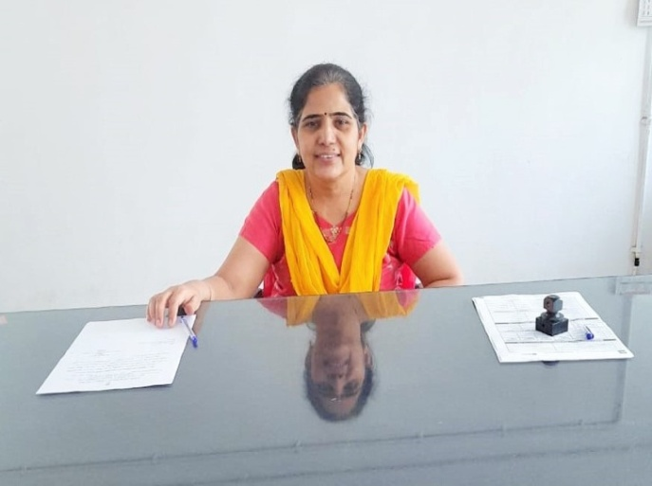

1. **Assistant Professor**

Name:- Dr. Chaitali Mirajkar Qualification:- B.D.S, M.D.SEmail ID:- chaitalimirajkar@gmail.com

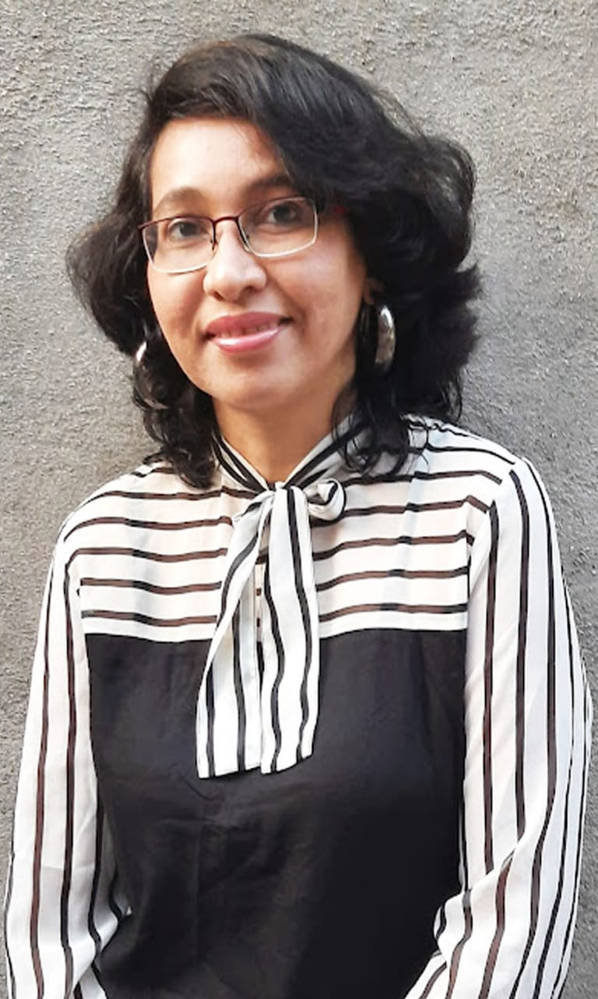

1. **Assistant Professor**

Name:- Dr. Shivani Nagnath Bhadule

Qualification – B.D.S, M.D.S

Email ID:- shivani23bhadule@gmail.com

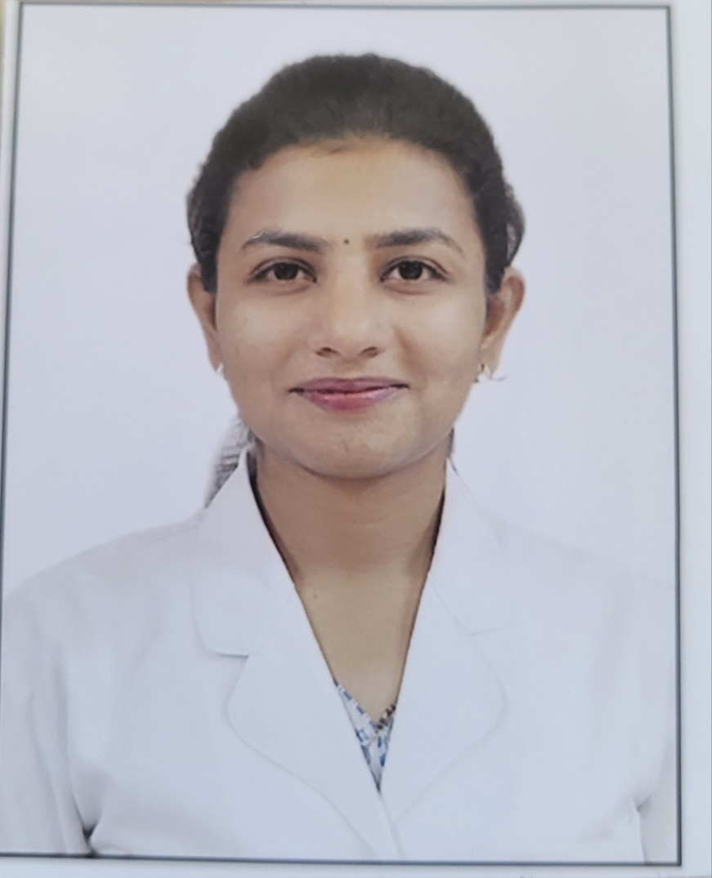

1. **Dental Surgeon**

Name:- Dr. Anita Gaikwad

Qualification – B.D.S

Email ID:- dranitagka@gmail.com

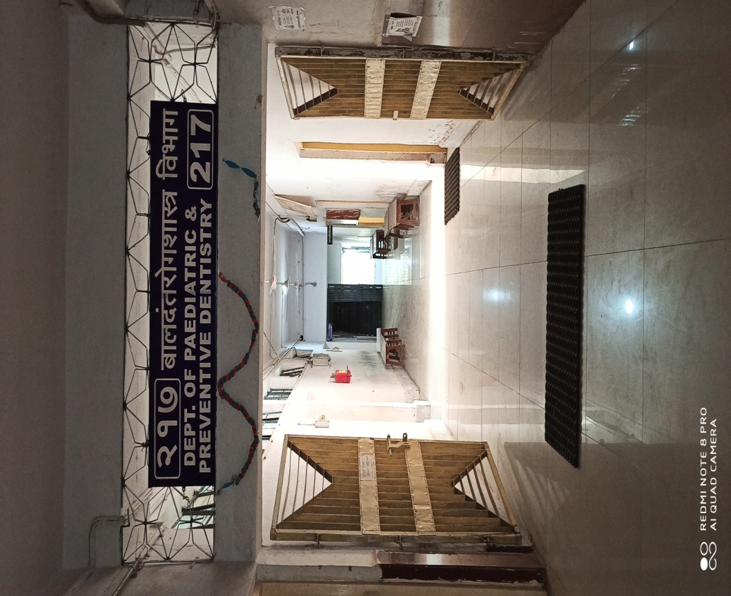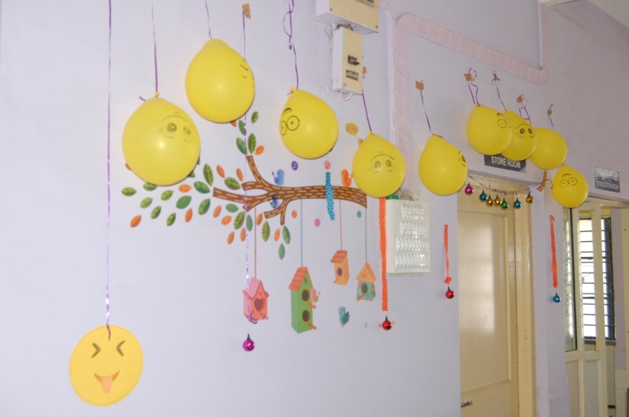

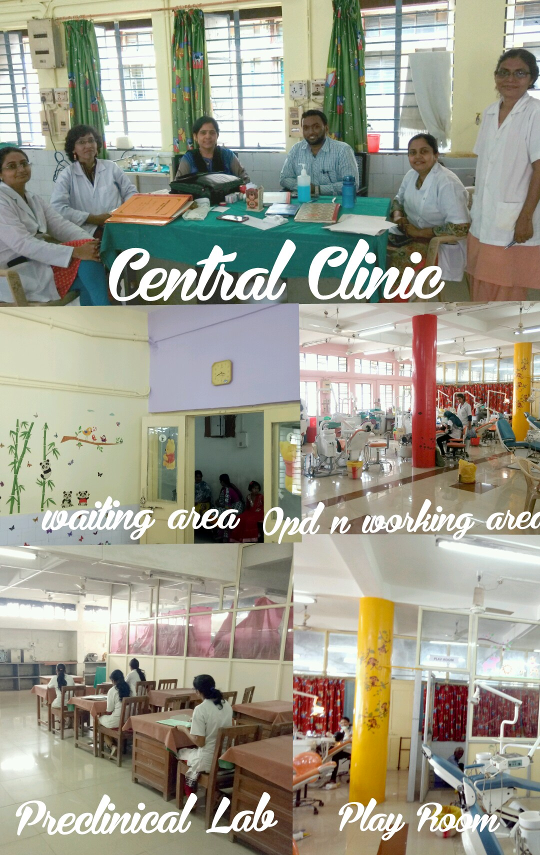

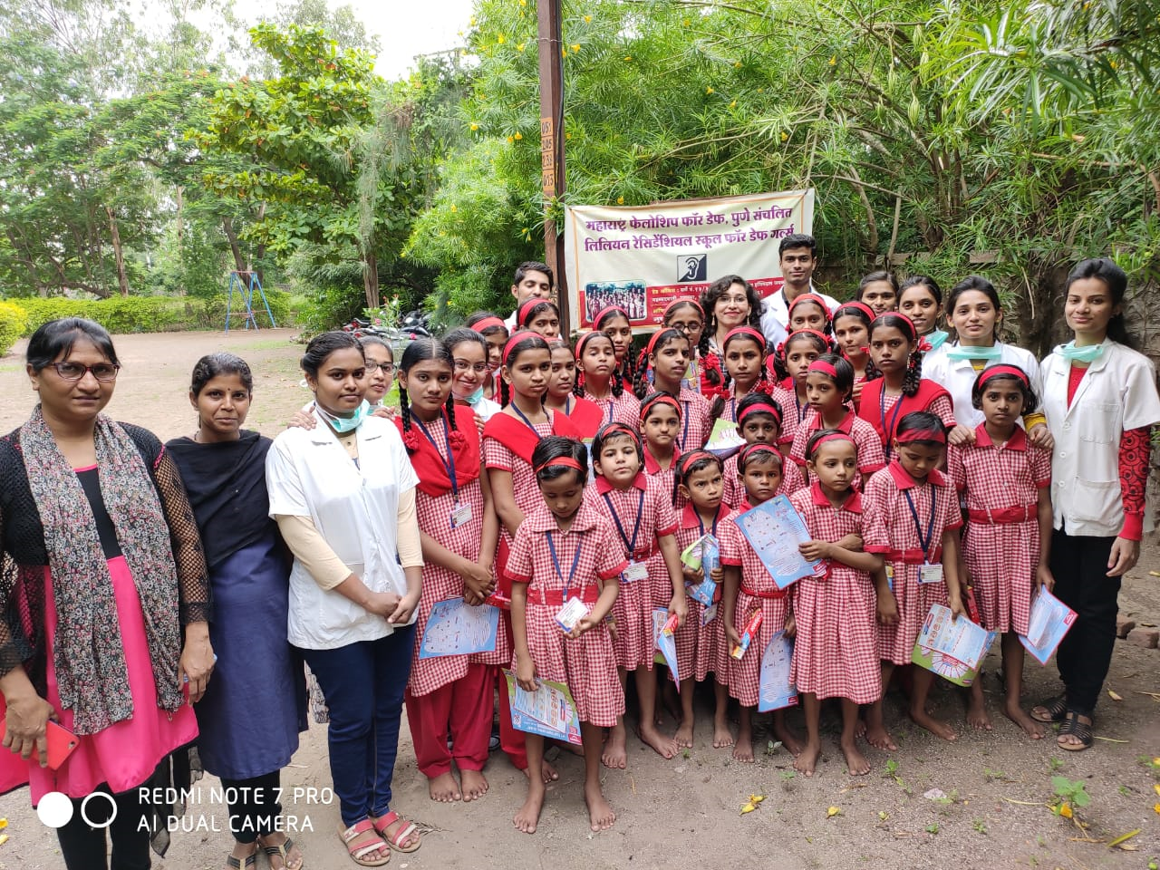

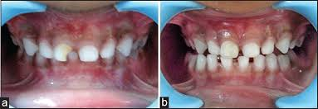

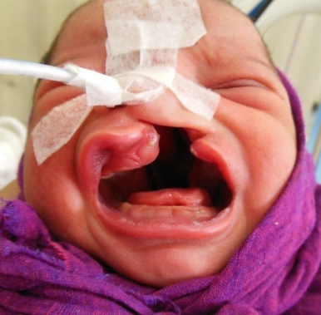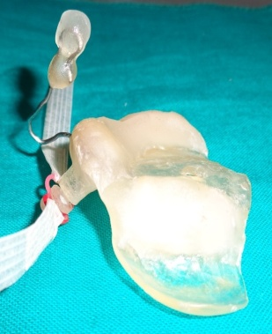

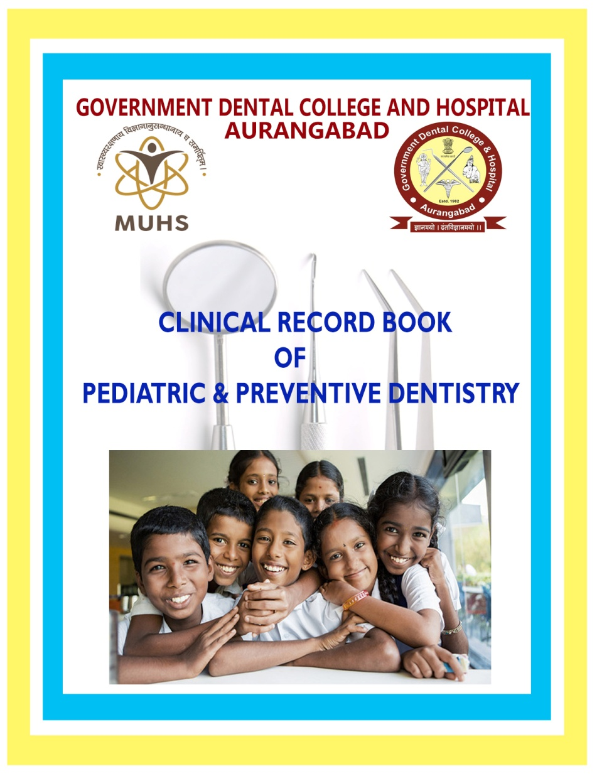

**baaladMta raogaSaas~a ivaBaaga**

baaladMta raogaSaas~a ivaBaaga sampauNa_ marazvaaDyaata ho ekxmaova SaasakxIya r}gNaalaya Aaho ,jaoqao maulaaMcyaa dataaMcyaa {parasaazI ivaSaoYa ivaBaaga Aaho.hyaa ivaBaagaata 13 vaYaa_ paya_Mtacyaa maulaaMcyaa dataaMcyaa {pacaar haotaata.ApaMga va mataImaMd maulaaMcyaa dMtar}gNaaopacaarakxrItaa doKaIla ivaBaagaata ivaSaoYa sauivaQaa Aahota. ivaBaagaata maulaaMcyaa dMtar}gNaaopacaarakxrItaa AaQauinakx {pacaar paQdtaI Aahota. ivaBaagaamaQyao paonalaosa AanaosqaoiSayaa maiSana Aar.iva.jaI maiSana, enDaomaaoTr,ApaoWsa laaokxoTr,palpa TosTr {palabQa Aaho. ivaBaagaataIla maQyavataI_ {pacaar ivaBaaga maulaaMnaa AavaDola ASaa ica~aaMnaI ,vaogavaogaLyaa rMgaanaI va rMgaIta CbaIdar paDdyaanaI sajavaNyaata Aalaa Aaho. {pacaaradrmyaana maulaaMcao laXa ivacalaIta kxrNyaasaazI durica~avaahInaI caI vyavasqaa Aaho.

baaladMtaraogSaas~a ivaBaagaata yaaogya va {ccadjaa_cao {pacaar kxolao jaataata. dataata isamaoMT va caaMdI BarNao r}T kxVnala {pacaar ,ApaoWsaaojaoinasaIsa va ApaoWisaifxkxoSana kxrNyaata yaotao. dataaMnaa ikxD na laagaNyaasaazI flaaora[_D va ipaT AaiNa ifxSar saarKao ikxDpa`itabaMiQata {pacaar kxolao jaataata. duQaacao data vaoLo Aagaaodr paDlyaasa eoNaa%yaa dataaMcaI rcanaa vyavaisqata haoNyaakxrItaa spaosa maonaTonar va spaosa irgaonar saarKaI {pacaar paQdtaI doKaIla {palabQa Aahota. kxahI navajaata iSaSaunaa fxaTlaolyaa TaLu mauLo duQaipaNyaasa ~aasa haotaao, ASaa maulaaMkxrItaa ivaBaagaata ivaSaoYa ifxDIMgaplaoT tayaar kxrNyaacaI sauivaQaa doKaIla {palabQa Aaho.

ivaBaagaata baaladMtaraoga ivaYayaacao padvaIpauva_ iSaXaNa idlao jaatao. yaa ivaYayaacaI maaihtaI ivadyaaqaa_Mnaa vyaaKaana va pa`atyaaiXakxaMnad\vaara pa`iSaXaNa idlao jaatao. ivaBaagaad\vaara vaogavaogaLyaa SaaLota, maitamaMd va mauKabaiQar maulaaMcyaa SaaLota va baalasauQaar gaRhata dMta tapaasaNaI iSaibar Aayaaoijata kxolao jaataata.

**baaladMtaraogaSaas~a ivaBaaga**

|  |
| --- |
| C:\Users\Admin\Downloads\IMG-20210108-WA0002 (3).jpg |

**naava:-** DaV. isamaa paazkx

**SaOXaiNakx Ah_taa**:-baI.DI.esa ,ema.DI.esa.

**[_ maola AayaDI**:- seemadpathak@gmail.com

1. **[maartaItaIla sqaana** : dusara majalaa , 217 ivaBaaga
2. **ivaBaagaacaI vyaataI** : padvaIpauva_ AByaasakx`maata baaladMtaraogaSaas~a ivaYayaaMcao pairpaUNa_ iSaXaNa idlao jaatao. dMtaraogaaMcaa pa`itabaMQa, Acaukx inadana va duQadataaMvairla tasaoca kxayamacyaa dataaMvairla sava_ dMtaraogaaMvar, saMbaMiQata ihrDyaa, hD\DIMcyaa raogaaMvar {pacaar; [tar dMta va vaOdyaikxya SaaKaaMcyaa ivaivaQa ivaBaagaaMSaI saMpakxa_ta rahUna {pacaaraMnaa jaaoD doNao; 13 vaYaa_paya_Mtacyaa duQa_r Aajaaranao ipaiDta vaa Sairr vaa bauiQdnaoo idvyaaMga maulaaMcyaa Aa[_vaiDlaaMcao samaupadoSana kxrNao. padivapa`apta ivadyaaqaa_Mcao padvyauttar iSaXaNaakxirtaa va r]gNaaopacaarakxirtaa samaupadoSana kxrNao.
3. **r}gNasaovaa ({pacaar) :** saMpauNa_ marazvaaDyaata ho ekxmaova SaasakxIya r}gNaalaya Aaho ,jaoqao maulaaMcyaa dataaMcyaa {parasaazI ivaSaoYa ivaBaaga Aaho.hyaa ivaBaagaata 13 vaYaaM_paya_Mtacyaa maulaaMcyaa dataaMcao sava_ {pacaar haotaata. idvyaaMga va mataImaMd maulaaMcyaa dMtar}gNaaopacaarakxrItaadoKaIla ivaBaagaata ivaSaoYa sauivaQaa Aahota. ivaBaagaata maulaaMcyaa dMtar}gNaaopacaarakxrItaa AaQauinakx {pacaar paQdtaI Aahota. ivaBaagaamaQyao paonalaosa AanaosqaoiSayaa maiSana, Aar.ivh.jaI. maiSana, enDaomaaoTr, ApaoWsa laaokxoTr, palpa TosTr {palabQa Aaho. ivaBaagaataIla maQyavataI_ {pacaar ivaBaaga maulaaMnaa AavaDola ASaa ica~aaMnaI, vaogavaogaLyaa rMgaanaI va rMgaIta CbaIdar paDdyaaMnaI sajaivaNyaata Aalaa Aaho. {pacaaradrmyaana maulaaMcao laXa ivacalaIta kxrNyaasaazI plao r}ma va durica~avaahInaIcaI vyavasqaa Aaho.

baaladMtaraogaSaas~a ivaBaagaata sauyaaogya va {cca djaa_cao {pacaar kxolao jaataata. dataata isamaoMT va caaMdI BarNa,o r}T kxVnala {pacaar ,ApaoWsaaojaoinasaIsa va ApaoiWsaifxkxoSana kxrNyaata yaotao. dataaMnaa ikxD na laagaNyaasaazI flaaora[_D va ipaT AaiNa ifxSar ifxilaMga saarKao ikxDpa`itabaMiQata {pacaar kxolao jaataata. duQaacao data vaoLo Aagaaodr paDlyaasa yaoNaa%yaa dataaMcaI rcanaa vyavaisqata haoNyaakxrItaa spaosa maMonaTonar va spaosa irgaonar saarKaI {pacaar paQdtaI doKaIla {palabQa Aahota. kxahI navajaata iSaSaunaa fxaTlaolyaa TaLu mauLo duQa ipaNyaasa ~aasa haotaao, ASaa maulaaMkxrItaa ivaBaagaata ivaSaoYa ifxDIMgaplaoT tayaar kxrNyaacaI sauivaQaa doKaIla {palabQa Aaho.

1. **{pakx`ma :-** ivadyaaqaa_Mnaa ivaBaagaata baaladMtaraoga ivaYayaacao padvaIpauva_ iSaXaNa dotaaota, yaa ivaYayaacaI maaihtaI pa`iSaXaNa, vyaaKaanao va pa`atyaaiXakxaMd\vaara dotaaota. drvaYaI_pa`maanao yaahI vaYaI_ ivaBaagaamaQyao 14 naaovhoMbar raojaI baalaidna saajara kxolaa gaolaa. tyaaca idvaSaI ivaBaagaad\vaara vaogavaogaLyaa SaaLota, maitamaMd va mauKabaiQar maulaaMcyaa SaaLota va baalasauQaar gaRhata dMta tapaasaNaI iSaibar Aayaaoijata kxr}na, iSaibarataIla maulaaMcyaa dataaMcao {pacaar tyaa maihNyaaBarata ivaBaagaamaQyao kxolao. आMganavaaDI saoivakxaMnaa tasaoca pa`aqaimakx SaaLotaIla iSaXakxaMnaa maulaaMcyaa dMtaAaraogyaasaMbaQaI maaga_dSa_na kxr}na tyaaMcao samaupadoSana kxolao. ivaBaagaataIla AiQakxarI

va kxma_caa%yaaMnaI kxaoivaD 19 cyaa vaaD_maQyao kxamao kxolaI.